A drone simulator
The idea is to create this program in C# with HelixToolkit package.

Remote controller test
Gamepad Tester - Check Controllers and Joysticks Online (hardwaretester.com)
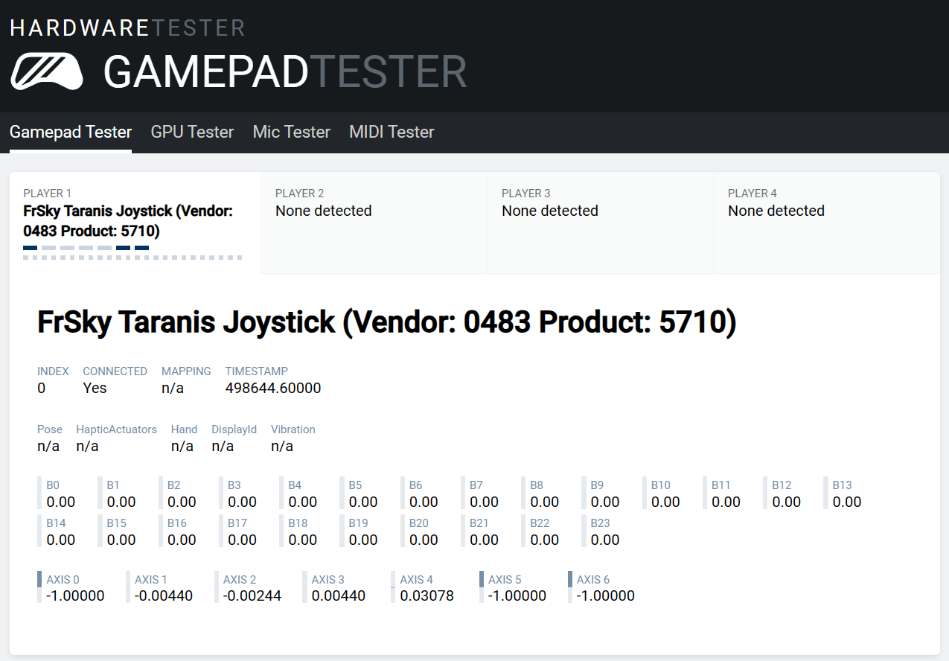
Axis0 = throttle Axis2 = pitch
Axis3 = yaw Axis1 = roll
(1) = B0
(2) = B1
(3) = Axis5
(4) = nothing
(5) = Axis4
(6) = Axis6
